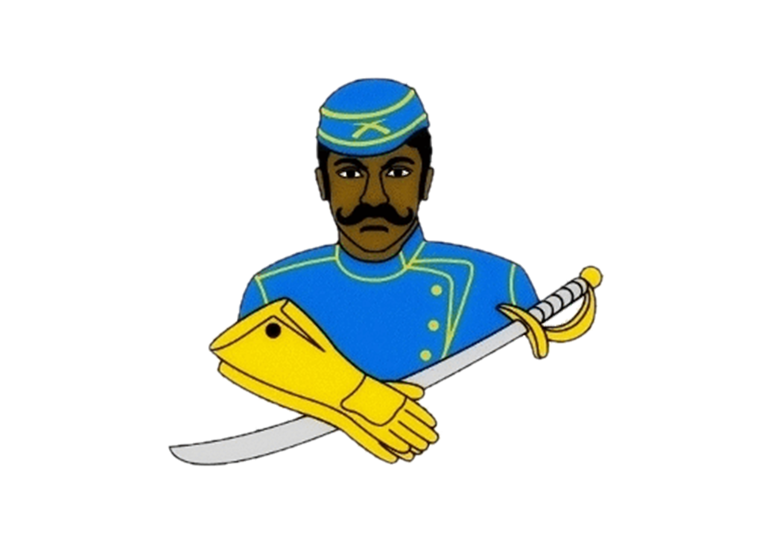
National Association of Buffalo Soldiers & Troopers Motorcycle Club (NABSTMC)
2024 Buffalo Soldiers Motorcycle Club Columbia Scholarship Program

Dear Scholarship Coordinators/Counselors/Students:

The Columbia South Carolina Chapter of Buffalo Soldiers Motorcycle Club (CSCBSMC) is one of 30 chapters in the Southeast Frontier of the National Association of Buffalo Soldiers and Troopers Motorcycle Club (NABSTMC).

The CSCBSMC will award a one-time scholarship in the sum of $500.00 to 4 graduating high school seniors/GED recipients who desire to further their education and training beyond high school, reside in the chapter’s service area (Richland, Kershaw, Lexington, Fairfield, Newberry, Lee, Sumpter, Calhoun, Orangeburg, Aiken, Edgefield, Clarendon, and Saluda Counties) and demonstrate a financial need.

The scholarships will be awarded based on a completed application packet, student qualifications, an essay and supporting documentation. Scholarship recipients will receive their financial award upon enrollment verification at the college/university the student will be attending.

Additionally, the scholarship recipient will be submitted for consideration of the Southeast Frontier Scholarship.
Each Frontier winner will participate in an interview process and be vetted by the National Scholarship Committee to determine the National Scholarship Winner.

Requirements of Each Applicant:
- Must be a graduating High School Senior/GED/High School Equivalency recipient during the 2023 Fall / 2024 Summer school year, who will be attending post-secondary or vocational/trade school in the fall of 2024 with a minimum GPA of 2.0.
- Official High School Transcript, Home School Transcript, or GED/High School Equivalency test scores (no GED certificate)
- Letter of recommendation on official letter head from a teacher/guidance counselor/school administrator.
- Letter of recommendation on letterhead from a community service organization.
- Letter of acceptance to an institution of higher learning.

Applicant Instructions:
- Prepare and upload a letter of introduction, who you are, your accomplishments to date, family background, and the degree to which you are seeking, and financial need. Provide a summary of how you plan to use the scholarship if selected.
- Attach/upload a recent professional headshot photo (In Good Taste).
- Attach/Upload your transcripts or test scores, both letters of recommendation and your letter of acceptance.
- Complete and upload the 2024 Buffalo Soldiers Motorcycle Club Columbia Chapter scholarship application.
- Upload a 500-word essay on the topics described below.
- What impact did the Buffalo Soldiers make in war and/or peacetime? Why is it necessary to pass this legacy on to future generations?

- Provide specific examples of how the Buffalo Soldiers facilitated the development of roadways, national parks, and mail service.

- The Congressional Medal of Honor is presented to the recipient by the President of the United States in the name of Congress. Please provide a brief narrative regarding a Buffalo Soldier who received this honor and what can be learned from his/her life, efforts, and commitment to duty.
Essay Guidelines
- Contain a minimum of 500 words.
- Typewritten/Digital Uploaded
- Double Spaced
- Times New Roman 12 Point Font
- 1” Margins
- Written in American Psychological Association (APA) format. Neither footnotes, nor a bibliography can be substituted for in-text citations.
- Sources must come from a combination of the following mediums: magazines, books, and the Internet.
- You are responsible for properly citing your references to avoid any form of plagiarism. Any plagiarized content will disqualify your application.
- Submit Packet: Completed application and all required documents must be attached as a MS Word document or scanned in PDF format. Submit all documents in ONE (1) PDF file and email to cscbsmcscholarships@gmail.com on or before March 20, 2024. The subject line is your full name, city, and state. Applications must be vetted and forwarded from the local Buffalo Soldiers Motorcycle Club chapter to the Frontier Chairperson.
Incomplete or late applications will be disqualified. No exceptions.

Application Deadline: March 20, 2024

2024 Buffalo Soldiers Motorcycle Club Columbia Scholarship Application
Application Deadline March 20, 2024

Personal Information:
First Name: |  | Last Name:
Address:
City: |  | State:
Zip Code: |  | Email:
Home Phone: |  | Cell Phone:
Date of Birth:

Academic Information:
High School Name: |  | City / State
Graduation Date:

College Information (If you have not finalized your college choice, provide your first-choice school.):
College Name: |  | City / State:
Institution Type:
Certificate Four-Year Two-Year Vocational or Technical:
Degree Sought: Associates Bachelor’s Certificate
Major:
Anticipated
Graduation Date:
Are you a first generational college student?
Office of Financial Aid Address

Photo Goes
Here

Applicant Service, Extracurricular Activities, and Work Experience:
Use this space to provide the applicant’s volunteer service, extracurricular activities, and work experience during the applicant’s academic career. Do not attach a resume in lieu of completing this form. It will not be reviewed.
Description
Total Hours or Average Hours per week: |  | Are you still participating? (yes/no)
Start Date: |  | End Date:
Highest Position Held:
Description
Total Hours or Average Hours per week: |  | Are you still participating? (yes/no)
Start Date: |  | End Date:
Highest Position Held:
Description
Total Hours or Average Hours per week: |  | Are you still participating? (yes/no)
Start Date: |  | End Date:
Highest Position Held:

Terms & Conditions:
I, , certify, to the best of my knowledge, that the information on this application is complete and accurate. Falsification of any information will cause my disqualification from the scholarship competition.
- It is my responsibility to make sure the application process is complete, and the entire application packet is sent or scanned to the nearest local National Association of Buffalo Soldiers & Troopers Motorcycle Club Chapter by the required deadline. If not, the application may be disqualified from the scholarship competition and may not be considered for an award.
- This application, upon receipt, becomes the property of the program sponsor.
I agree that, if selected as an award winner for the National Association of Buffalo Soldiers & Troopers Motorcycle Club Scholarship Program, the program sponsor or its agents may use my name and likeness and any other information or materials provided in connection with this program for purposes of news, publicity, and advertising in all media, including but not limited to print and electronic media, press releases, internet, websites, and video media.
To comply with the provisions of the Family Educational and Privacy Act of 1974, I hereby grant permission for school officials to release secondary school records and other requested information, if necessary.
If you are under 18, your parent or guardian must also agree to these Terms and Conditions.
Applicant Signature: Date:
Parent Signature: (if applicable)
** Local Chapter/Frontier must acknowledge receipt before sending to the National Scholarship Committee.
Chapter__________________________Signature____________________________________________

Valerie “Chocolate Sunshine” Prioleau,
Scholarship Committee Chair

cscbsmcscholarships@gmail.com

